CS-114 - Fundamental of Programing

Lab Manual # 05

Course Instructor: Dr. Talha

Lab Instructor: Muhammad Affan

Student Name: M. Moeez Zafar

CMS ID: DATE: 456063

Date: 27-10-2023

1. **Convert the following while loop to a do-while loop:**

int x = 1;

while (x > 0)

{

cout << "enter a number: ";

cin >> x;

}

As do while loop:

int x=1;

do  
{

cout << "enter a number: ";

cin >> x;

}

while(x>0);

1. **Use a do while loop to make a simple calculator for two numbers. Insert buttons for it to ask again and for termination.**

#include <iostream>

#include <math.h>

using namespace std;

int main()

{

int i=0;

while(i<1)

{

int num1=0,num2=0,answer;

cout<<"-------------------Please enter a number-------------------"<<endl;

cin>>num1;

cout<<"-----------------Please enter another number-----------------"<<endl;

cin>>num2;

char op;

cout<<"--------------Please enter your desired operation--------------"<<endl;

cout<<"---------------You can choose from(+,-,*,/,^,%)---------------"<<endl;

cin>>op;

switch(op)

{

case'+':

answer=num1 + num2;

break;

case'-':

answer=num1 - num2;

break;

case'*':

answer=num1 * num2;

break;

case'/':

if(num2!=0)

{

answer=num1 / num2;

}

else

{

cout<<"can not divide by zero"<<endl;

}

break;

case'^':

answer= pow(num1,num2);

break;

case'%':

answer=num1 % num2;

break;

default:

cout<<"wrong operator or operation"<<endl;

break;

}

cout<<"your answer is "<<answer<<endl;

cout<<"Do you want to continue?"<<endl;

cout<<"if yes press 'y' "<<endl;

cout<<"if no press 'n' "<<endl;

int j=0;

char choice;

cin >>choice;

switch (choice)

{

case'n':

j=0;

cout<<"thank you for using calculator"<<endl;

break;

case'y':

j=2;

break;

default:

cout<<"choose between 'y'and'n' "<<endl;

}

if(j<1)

{

i=i+2;

}

else

{

i=0;

}

}

return 0;

}

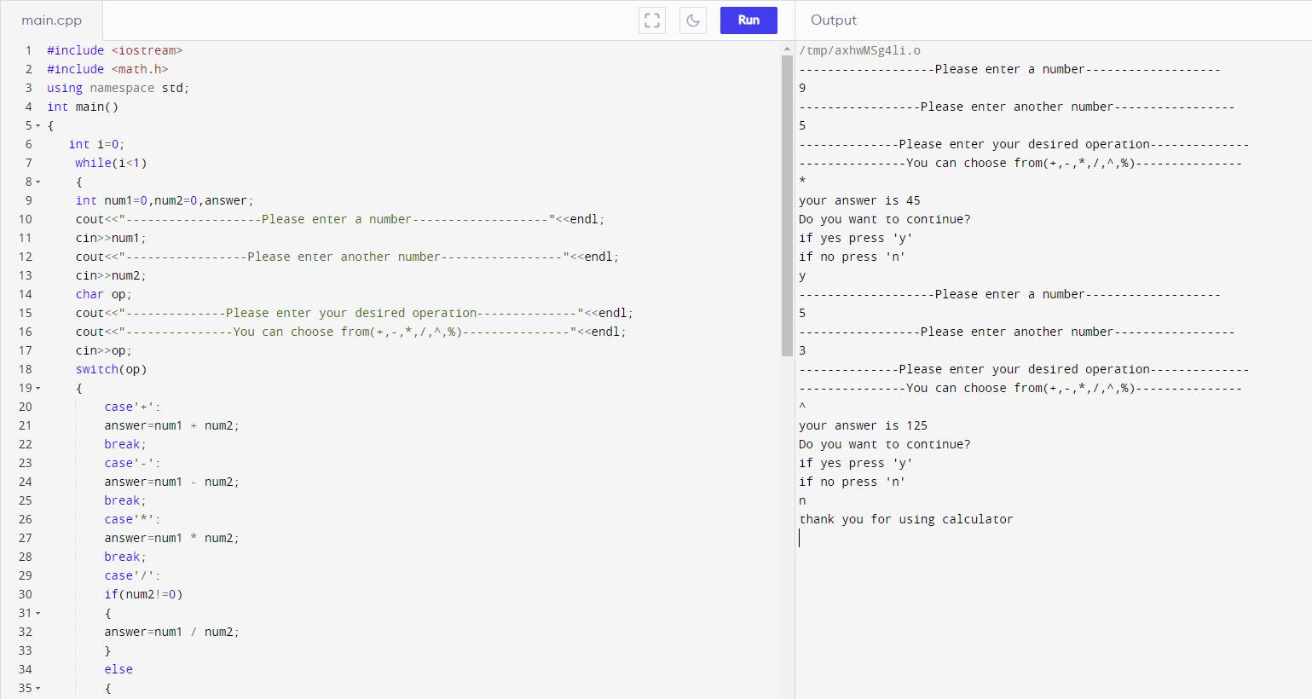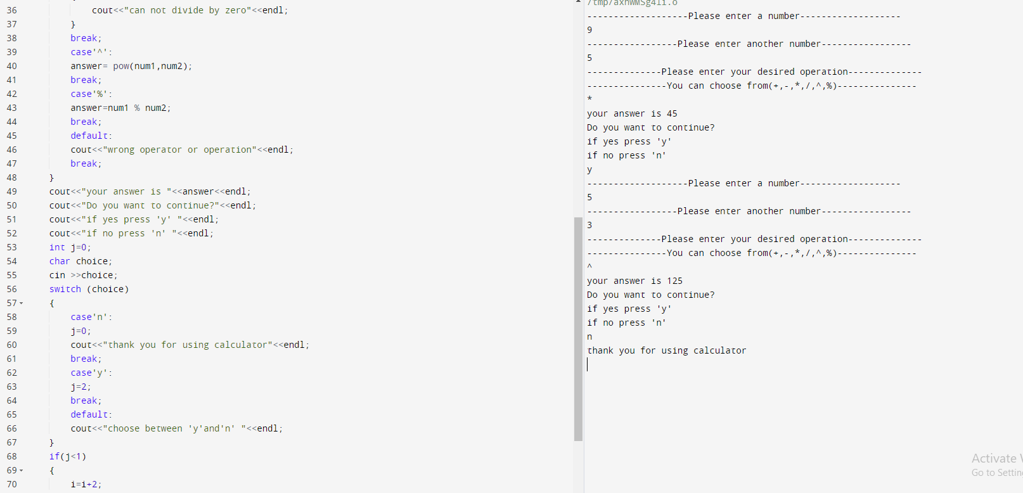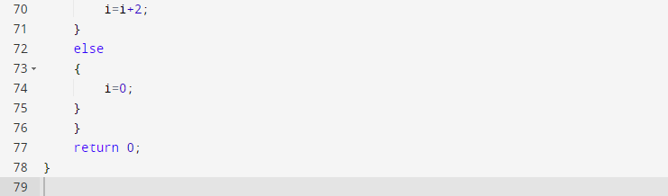

**3 Write programs with while or do while loops that compute:**

**a. The sum of all even numbers between 2 and 100 (inclusive).**

**b. The sum of all squares between 1 and 100 (inclusive)**

**a. The sum of all even numbers between 2 and 100 (inclusive).**

#include <iostream>

using namespace std;

int main()

{

int i=0;

int sum=0;

while(i<98)

{

if(i%2==0)

{

i=i+2;

cout<<i<<"+";

sum=sum+i;

}

}

i=i+2;

sum=sum+i;

cout<<i<<"="<<" "<<sum<<endl;

cout<<"the sum of even numbers from 2 to 100 is "<< sum;

}

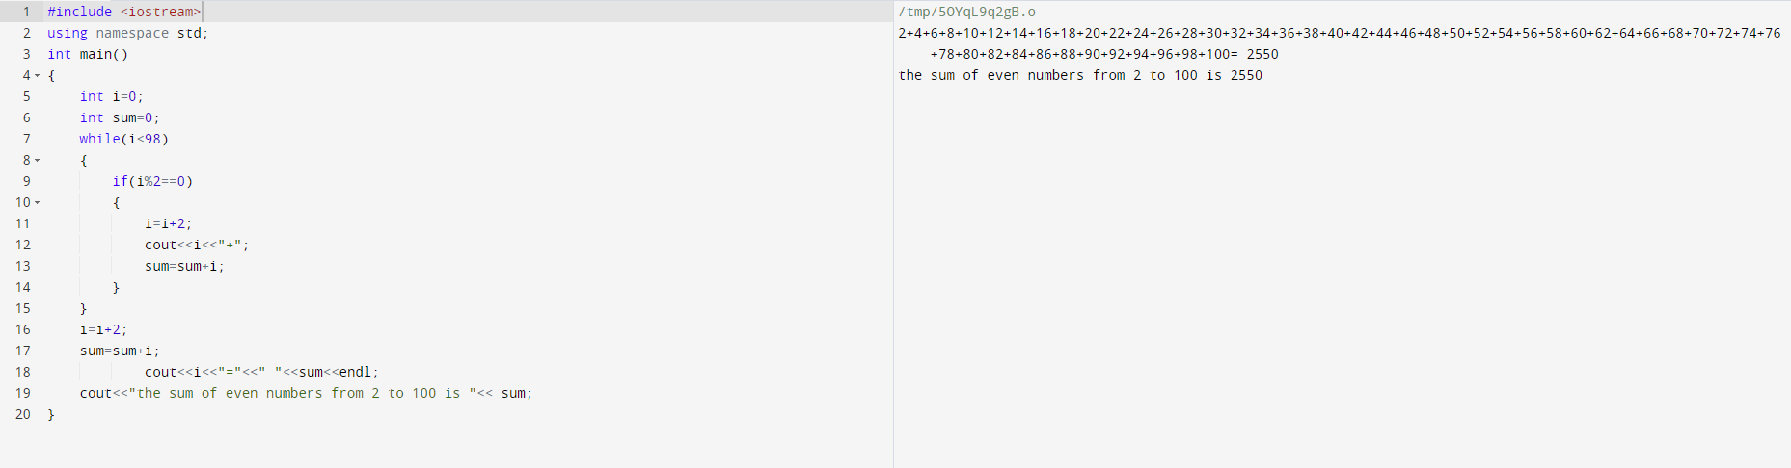

**b. The sum of all squares between 1 and 100 (inclusive)**

#include <iostream>

using namespace std;

int main()

{

int i=1;

int sum=0;

int j=1;

int square;

while(i<9)

{

i=i*j;

square=i;

cout<<i<<" "<<"+";

i=i/j;

i++;

j++;

sum=sum+square;

}

i=i*j;

square=i;

cout<<i<<" "<<"=";

i=i/j;

i++;

j++;

sum=sum+square;

cout<<sum<<endl;

cout<<"the sum of squares between 1 and 100 is "<< sum;

}

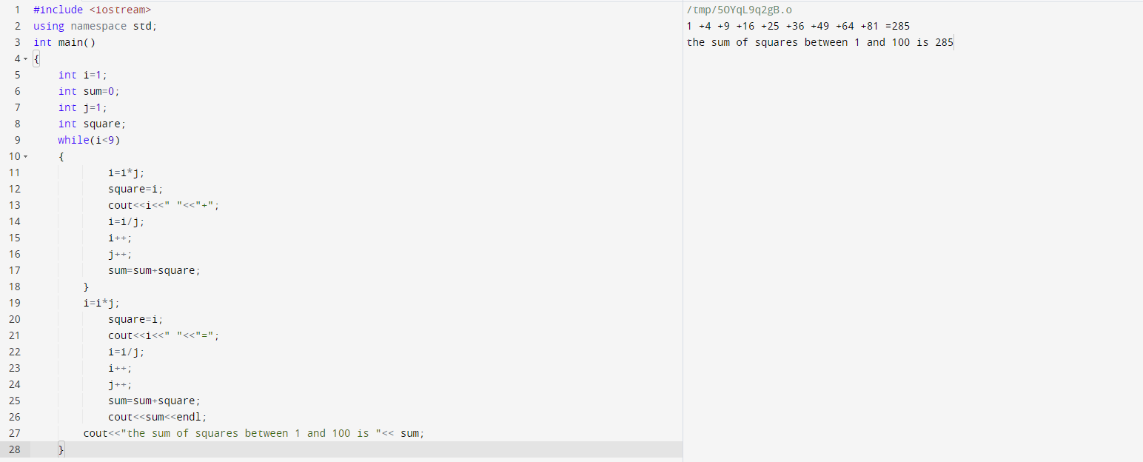

**4. Write programs with while or do while loops that compute:**

**a. All powers of 2 from 20 up to 220 .**

**b. The sum of all odd numbers between a and b (inclusive), where a and b are inputs.**

**a. All powers of 2 from 20 up to 220 .**

#include <iostream>

#include <math.h>

using namespace std;

int main()

{

int expo=0;

int answer=0;

while(expo<21)

{

answer=pow(2,expo);

cout<<"2^"<<expo<<" = "<<answer<<endl;

expo++;

}

}

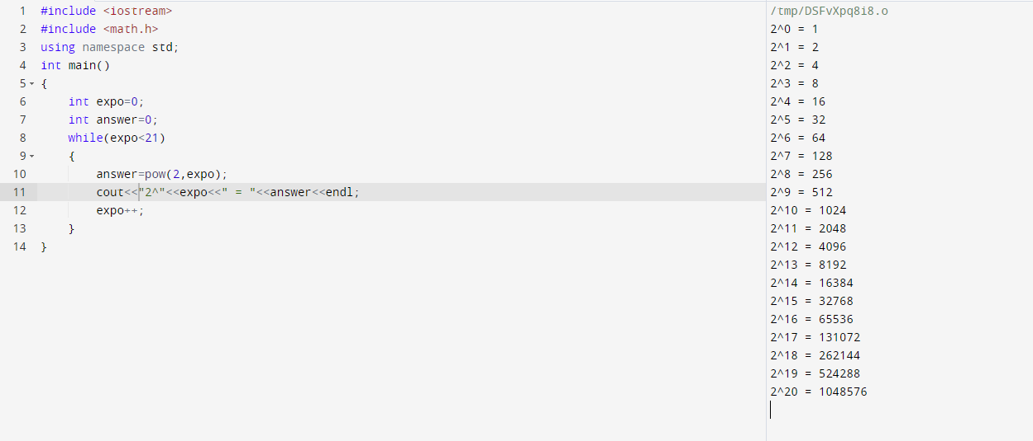

**b. The sum of all odd numbers between a and b (inclusive), where a and b are inputs.**

#include <iostream>

#include <math.h>

using namespace std;

int main()

{

int numg=0,nums=0,odd=0,sum=0;

cout<<"Enter any number"<<endl;

int num1=0;

cin >>num1;

cout<<"Enter another number"<<endl;

int num2=0;

cin>>num2;

if(num1>num2)

{

numg=num1;

nums=num2;

}

else

{

numg=num2;

nums=num1;

}

if(numg-nums>1)

{

while (nums<numg)

{

nums++;

if(nums%2==1)

{

sum=sum+nums;

}

}

}

cout<<"The Sum of Odd Numbers between"<<num1<< "and"<<num2<<" = "<<sum<<endl;

}

